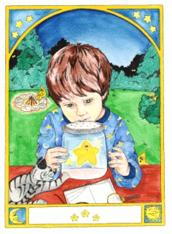
Christine Almstrom
Children’s & Young Adult Author/Illustrator
________________________

Photo Release Form for Minors (under 18)

This permission grants Christine Almstrom – Author/Illustrator - the use of my child(ren)’s photograph publically to promote her website, books, events, and/or illustrations. I understand that the images may be used in print publication, online publications, presentations, websites, and social media. I also understand that no royalty, fee or other compensation shall become payable to me by reason of such use.

Parent/Guardian Signature: _______________________________ Date: _________________

Parent/Guardian Name (printed): _______________________________

Child(ren)’s Name: _____________________________________________________________

Phone Number: _______________________________________

